|  |
| --- |
|  |
|  |  |

**TEST SUMMARY REPORT FOR BEWAKOOF SHOPPING WEB APPLICATION**

**TABLE OF CONTENT**

1. Purpose 3
2. Application Overview 3
3. Testing Scope 3
4. Metrics 4
5. Types of Testing Performed 5
6. Test Environment 6
7. Lessons Learnt 7
8. Recommendations 7
9. Best Practises 7
10. Exit Criteria 7
11. Conclusion 8

**1.PURPOSE:** This document is the software test report of the **Bewakoof Shopping Web Application** in Phase of User. It contains the results of tests, which were executed during the testing.

**2. APPLICATION OVERVIEW:**

Online Shopping is a lifestyle e-commerce web application, which retails various fashion and lifestyle products (Currently Men’s and Women’s wear). This project allows viewing various products available enables registered users to purchase desired products instantly using Card payment, Net banking and UPI processor (Instant Pay) and also can place order by using Cash on Delivery (Pay Later) option. This project provides an easy access to Administrators and Managers to view orders placed using Pay Later and Instant Pay options. The main purpose of this Shopping application is where product like clothes can be bought from the comfort of home through the Internet.

**3. TESTING SCOPE**

**In Scope:**

Functional Testing for the following modules are in Scope of Testing.

* Registration page
* Login page
* Search option
* Add to cart Method
* Payment option
* Tracking Order.

**Out of Scope:**

Recovery Testing is not done for this application. This can be tested after any failure of data.

**Items not Tested:**

Showing relevant items to a particular product within the price range and guest visit to the application (Third party User) has not done.

**4. METRICS:**

|  |  |  |  |
| --- | --- | --- | --- |
| Test cases Planned | Test cases Executed | Test cases passed | Test cases failed |
| 35 | 34 | 33 | 2 |

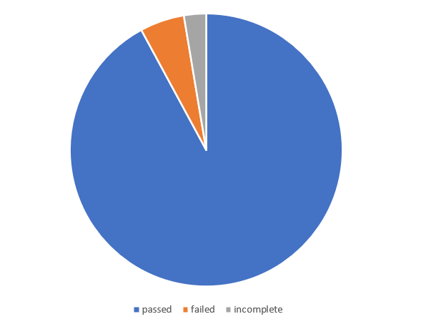

**5.TYPES OF TESTING**

* **FUNCTIONAL TESTING:**

A [test case](https://qatestlab.com/resources/knowledge-center/sample-deliverables/software-testing-templates-list/) is a set of preconditions, procedures (inputs or actions), and expected results used to determine whether a system works correctly. Test cases should have the following structure: a brief statement of purpose, description of precondition, actual test case inputs, expected outputs, description of expected postconditions, and execution history (date/person in charge/product version/pass or fail result).

* **USABILITY TESTING :**

Usability testing is defined as the evaluation of a product by testing it on potential users. To test how users will add multiple items in the cart. Is it easy for them to set the prices in their desired currency? Can they choose their preferred payment method without any hassle? if users can pick the payment methods they want, you can evaluate whether the website shows payment methods valid for the user’s country.

* **INTERFACE TESTING :**

ensure that end-users or customer should not encounter any problem when using Application. to check its user-friendliness as well. To verify security requirements while communication propagates between the systems and check if a solution is capable to handle network failures between an application server and website.

* **COMPACTIBILITY TESTING :**

It helps avoid issues related to versions updates, navigation flows, screen size adaptation, broken tables or frames, etc.  and the testing will done in

* Testing on PC, on different browsers like Safari, Chrome, Firefox, IE.
* Testing on different mobile devices that have different platforms like iOS, Android or Windows.
* Testing on networks like 4G, 3G or wifi.
* Testing on multiple operating systems such as Mac, Windows, Linux.
* **PERFORMANCE TESTING :**

Performance Testing is that type of software testing that pinpoints on how a system running the system performs under a particular circumstance. Performance testing measures depending on the benchmarks and standards. Performance testing helps the developers to eliminate the bottlenecks. Performance of a mobile or a web application is basically its capability of performing all the functions which it is supposed to do flawlessly without causing any delay or complication. its primary work, such as loading pages, showing the products, bringing out proper search results for the viewers, and loading the pages on time as well.

**6. TEST ENVIRONMENT & TOOLS :**

**Software Requirements:**

* **Operating System:** Unix, Linux, Windows.
* **Development tool**: JAVA development toolkit.
* **Databases**: MySQL

Hardware Requirements :

* Processor : Pentium or higher.
* RAM : 312MB or Higher.

**7. LESSONS LEARNT :**

A customer makes online payment by credit, debit card or net banking, or any other digital wallets, failure of digital payments can be frustrating. A technical issue with your website or faltering internet connection results in the payable amount being debited from the customer’s account but the same is not credited to the seller’s account. Retrieving the amount isn’t a quick process. It should be clearly mentioned on your website that it may take around 7-10 working days before the money is refunded to their bank accounts. Such situations can improve with cashless transactions.

Users would like to browse and explore different products. A slow loading website can frustrate the users and they may leave your site without purchasing anything. They might look for the same product at your competitor’s site. eCommerce store owners should aim at maintaining a fast loading speed where an each takes less than 3 seconds to load.

**8. RECOMMENDATIONS :**

Write the test cases during the requirement analysis and design phase. This way we can ensure all the requirements are testable. While writing test cases, write test case for intended functionality first i.e., for valid conditions according to requirements. Then write test cases for valid conditions. This will cover the expected as well as unexpected behaviour of an application during tests.

**9. BEST PRACTISES :**

A repetitive task done manually every time was time consuming. This task was automated by creating scripts and run each time, which saved time and resources.

* Test cases were automated and the scripts were run, which ran fast and saved time.
* Automation scripts were prepared to create new customers, where lot of records need to be created for Testing.
* Business critical scenarios are separately tested on the entire application which are vital to certify they works fine.

## 10. EXIT CRITERIA :

The team of testers are able to conclude the testing without compromising the quality and effectiveness of the software.

* Execution of all test cases has completed.
* All the identified defects are corrected and closed.
* No high priority or severity or critical bug has been left out.

## 11.CONCLUSION

A test summary report, therefore, is a necessary document and marks the conclusion of a software testing exercise. [Test engineers](https://codoid.com/who-are-the-custodians-of-software-quality/) must invest time and effort to complete such reports to maintain clarity and transparency of their efforts and provide clients with a clear summation of the project. This report requires the attention and time of experts and experienced personnel because of the critical nature of the content.